**WEEK 8 – ASSIGNMENT**

**Superset ID:** 6390124

**Git Exercises:-**

**Exercise 1:**

**Step 1: Setup your machine with Git Configuration**

To create a new repository, signup with GitLab and register your credentials

Login to GitLab and create a “GitDemo” project

1. To check if Git client is installed properly: Open Git bash shell and execute



If output shows Git with its version information that indicates, that Git Client installs properly.

1. To configure user level configuration of user ID and email ID execute



1. To check if the configuration is properly set, execute the following command.



**Step 2: Integrate notepad++.exe to Git and make it a default editor**

1. To check, if notepad++.exe execute from Git bash



If Git bash could not able to recognize notepad++ command that implies notepad++.exe is note added to the environment path variable.

To add path of notepad++.exe to environment variable, go to control panel -> System -> Advanced System settings. Go to Advanced tab -> Environment variables -> Add path of notepad++.exe to the path user variable by clicking on “Edit”

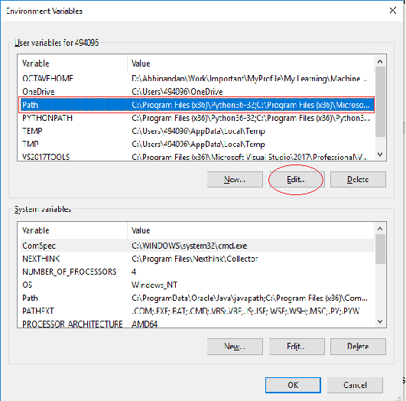

1. Exit Git bash shell, open bash shell and execute



Now, notepad++ will open from Git bash shell

1. To create an alias command for notepad++.exe, execute



It will open notepad++ from bash shell, and create a user profile by adding the line in notepad++



1. To configure the editor, execute the command



1. To verify if notepad++ is the default editor, execute the command



Here ‘-e’ option implies editor

It will show the entire global configuration as shown below,

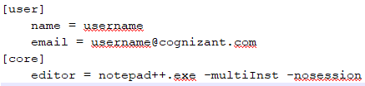

**Step 3: Add a file to source code repository**

1. Open Git bash shell and create a new project “**GitDemo**” by executing the command



1. Git bash initializes the “**GitDemo**” repository. To verify, execute the command

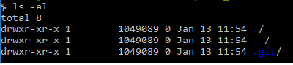

It will display all the hidden files in the Git “working directory”.

1. To create a file **“welcome.txt”** and add content to the file, execute the command



1. To verify if the file “welcome.txt” is created, execute

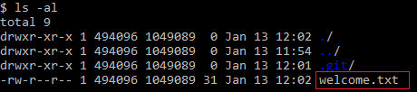

1. To verify the content, execute the command



1. Check the status by executing

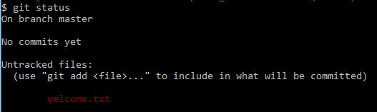

Now the file **“welcome.txt”** is available in Git “working directory”

1. To make the file to be tracked by Git repository, execute the command



1. To add multi line comments, we are opening default editor to comment. Execute the command



Notepad++ editor will open and to add multi-line comment with default editor

1. To check if local and “Working Directory” git repository are same, execute git status



**welcome.txt** is added to the local repository.

1. Signup with GitLab and create a remote repository **“GitDemo”**
2. To pull the remote repository, execute

**git pull origin master**

1. To push the local to remote repository, execute

**git push origin master**

SHARANBABU_B@DESKTOP-MN322RQ MINGW64 ~

$ git --version

git version 2.50.1.windows.1

SHARANBABU_B@DESKTOP-MN322RQ MINGW64 ~

$ git config --global user.name "SharanbabuB"

SHARANBABU_B@DESKTOP-MN322RQ MINGW64 ~

$ git config --global user.email "sharanbabu545@gmail.com"

SHARANBABU_B@DESKTOP-MN322RQ MINGW64 ~

$ git config --list

diff.astextplain.textconv=astextplain

filter.lfs.clean=git-lfs clean -- %f

filter.lfs.smudge=git-lfs smudge -- %f

filter.lfs.process=git-lfs filter-process

filter.lfs.required=true

http.sslbackend=schannel

core.autocrlf=true

core.fscache=true

core.symlinks=false

pull.rebase=false

credential.helper=manager

credential.https://dev.azure.com.usehttppath=true

init.defaultbranch=master

user.name=SharanbabuB

user.email=sharanbabu545@gmail.com

SHARANBABU_B@DESKTOP-MN322RQ MINGW64 ~

$ git config --global --list

user.name=SharanbabuB

user.email=sharanbabu545@gmail.com

SHARANBABU_B@DESKTOP-MN322RQ MINGW64 ~

$ notepad++

bash: notepad++: command not found

**After setting the path of Notepad++:**

SHARANBABU_B@DESKTOP-MN322RQ MINGW64 ~

$ notepad++

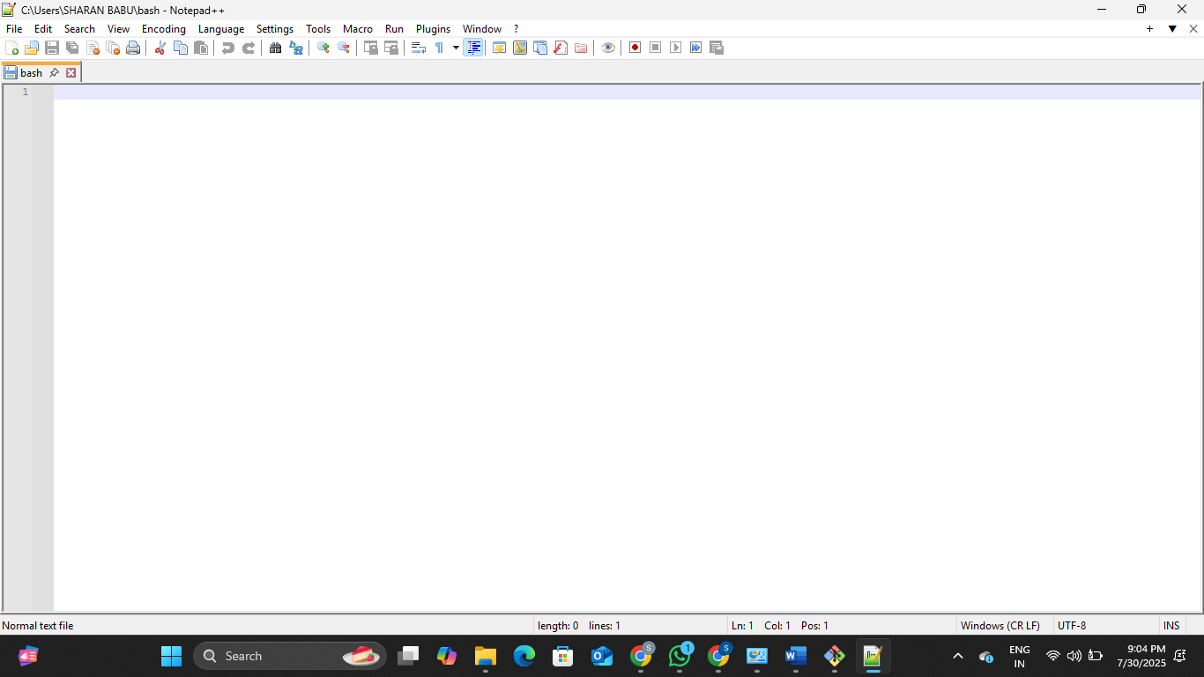

SHARANBABU_B@DESKTOP-MN322RQ MINGW64 ~

$ notepad++.exe bash -profile

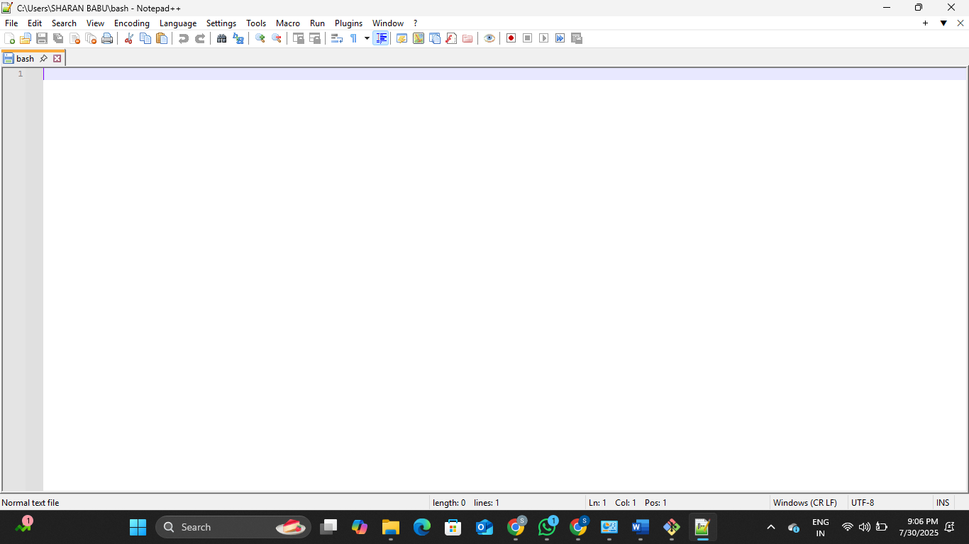

SHARANBABU_B@DESKTOP-MN322RQ MINGW64 ~

$ alias npp='notepad++.exe -multiInst -nosession'

SHARANBABU_B@DESKTOP-MN322RQ MINGW64 ~

$ git config --global core.editor "notepad++.exe -multiInst -nosession"

SHARANBABU_B@DESKTOP-MN322RQ MINGW64 ~

$ git config --global -e

hint: Waiting for your editor to close the file...

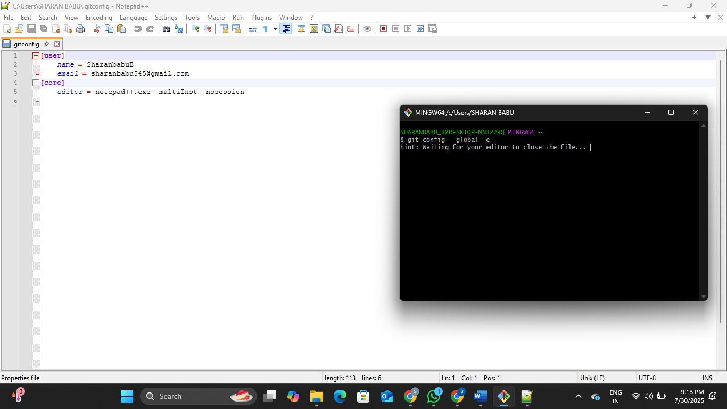

SHARANBABU_B@DESKTOP-MN322RQ MINGW64 ~

$ git init GitDemo

Initialized empty Git repository in C:/Users/SHARAN BABU/GitDemo/.git/

SHARANBABU_B@DESKTOP-MN322RQ MINGW64 ~

$ ls -al

total 11128

drwxr-xr-x 1 SHARANBABU_B 197121 0 Jul 30 21:14 **.**/

drwxr-xr-x 1 SHARANBABU_B 197121 0 Jul 26 15:14 **..**/

-rw-r--r-- 1 SHARANBABU_B 197121 361 Jul 30 19:36 .bash_history

drwxr-xr-x 1 SHARANBABU_B 197121 0 Jul 28 19:30 **.docker**/

drwxr-xr-x 1 SHARANBABU_B 197121 0 May 21 19:20 **.eclipse**/

-rw-r--r-- 1 SHARANBABU_B 197121 113 Jul 30 21:09 .gitconfig

drwxr-xr-x 1 SHARANBABU_B 197121 0 Mar 24 10:28 **.idlerc**/

-rw-r--r-- 1 SHARANBABU_B 197121 20 Jul 30 19:30 .lesshst

drwxr-xr-x 1 SHARANBABU_B 197121 0 Jun 29 13:29 **.m2**/

drwxr-xr-x 1 SHARANBABU_B 197121 0 Mar 1 14:01 **.ms-ad**/

drwxr-xr-x 1 SHARANBABU_B 197121 0 Mar 5 21:34 **.nuget**/

drwxr-xr-x 1 SHARANBABU_B 197121 0 Jul 23 16:41 **.p2**/

drwxr-xr-x 1 SHARANBABU_B 197121 0 May 20 17:26 **.redhat**/

drwxr-xr-x 1 SHARANBABU_B 197121 0 Jul 13 14:10 **.sts4**/

drwxr-xr-x 1 SHARANBABU_B 197121 0 Mar 1 13:52 **.vscode**/

drwxr-xr-x 1 SHARANBABU_B 197121 0 May 20 16:45 **AppData**/

lrwxrwxrwx 1 SHARANBABU_B 197121 36 May 20 16:44 **'Application Data'** -> **'/c/Users/SHARAN BABU/AppData/Roaming'**/

drwxr-xr-x 1 SHARANBABU_B 197121 0 May 20 16:55 **Contacts**/

lrwxrwxrwx 1 SHARANBABU_B 197121 64 May 20 16:44 **Cookies** -> **'/c/Users/SHARAN BABU/AppData/Local/Microsoft/Windows/INetCookies'**/

drwxr-xr-x 1 SHARANBABU_B 197121 0 Jul 3 22:03 **Desktop**/

drwxr-xr-x 1 SHARANBABU_B 197121 0 Mar 1 13:24 **Documents**/

drwxr-xr-x 1 SHARANBABU_B 197121 0 Jul 30 19:18 **Downloads**/

drwxr-xr-x 1 SHARANBABU_B 197121 0 May 20 16:55 **Favorites**/

drwxr-xr-x 1 SHARANBABU_B 197121 0 Jul 30 21:14 **GitDemo**/

drwxr-xr-x 1 SHARANBABU_B 197121 0 Mar 12 16:47 **IntelGraphicsProfiles**/

drwxr-xr-x 1 SHARANBABU_B 197121 0 Jun 18 21:55 **Learning_Program_Solutions**/

drwxr-xr-x 1 SHARANBABU_B 197121 0 May 20 16:55 **Links**/

lrwxrwxrwx 1 SHARANBABU_B 197121 34 May 20 16:44 **'Local Settings'** -> **'/c/Users/SHARAN BABU/AppData/Local'**/

lrwxrwxrwx 1 SHARANBABU_B 197121 30 May 20 16:44 **'My Documents'** -> **'/c/Users/SHARAN BABU/Documents'**/

-rw-r--r-- 1 SHARANBABU_B 197121 7077888 Jul 29 21:58 NTUSER.DAT

-rw-r--r-- 1 SHARANBABU_B 197121 65536 May 20 16:44 NTUSER.DAT{139b56a9-356b-11f0-969e-85be75f19ede}.TM.blf

-rw-r--r-- 1 SHARANBABU_B 197121 524288 May 20 16:44 NTUSER.DAT{139b56a9-356b-11f0-969e-85be75f19ede}.TMContainer00000000000000000001.regtrans-ms

-rw-r--r-- 1 SHARANBABU_B 197121 524288 May 20 16:44 NTUSER.DAT{139b56a9-356b-11f0-969e-85be75f19ede}.TMContainer00000000000000000002.regtrans-ms

lrwxrwxrwx 1 SHARANBABU_B 197121 72 May 20 16:44 **NetHood** -> **'/c/Users/SHARAN BABU/AppData/Roaming/Microsoft/Windows/Network Shortcuts'**/

drwxr-xr-x 1 SHARANBABU_B 197121 0 Jul 30 19:00 **OneDrive**/

drwxr-xr-x 1 SHARANBABU_B 197121 0 Jul 13 16:15 **Postman**/

lrwxrwxrwx 1 SHARANBABU_B 197121 72 May 20 16:44 **PrintHood** -> **'/c/Users/SHARAN BABU/AppData/Roaming/Microsoft/Windows/Printer Shortcuts'**/

lrwxrwxrwx 1 SHARANBABU_B 197121 61 May 20 16:44 **Recent** -> **'/c/Users/SHARAN BABU/AppData/Roaming/Microsoft/Windows/Recent'**/

drwxr-xr-x 1 SHARANBABU_B 197121 0 May 20 16:55 **'Saved Games'**/

drwxr-xr-x 1 SHARANBABU_B 197121 0 Jun 17 08:00 **Searches**/

lrwxrwxrwx 1 SHARANBABU_B 197121 61 May 20 16:44 **SendTo** -> **'/c/Users/SHARAN BABU/AppData/Roaming/Microsoft/Windows/SendTo'**/

lrwxrwxrwx 1 SHARANBABU_B 197121 65 May 20 16:44 **'Start Menu'** -> **'/c/Users/SHARAN BABU/AppData/Roaming/Microsoft/Windows/Start Menu'**/

lrwxrwxrwx 1 SHARANBABU_B 197121 64 May 20 16:44 **Templates** -> **'/c/Users/SHARAN BABU/AppData/Roaming/Microsoft/Windows/Templates'**/

-rw-r--r-- 1 SHARANBABU_B 197121 0 Jul 30 20:58 bash

drwxr-xr-x 1 SHARANBABU_B 197121 0 May 21 19:16 **eclipse**/

-rw-r--r-- 1 SHARANBABU_B 197121 1777664 May 20 16:44 ntuser.dat.LOG1

-rw-r--r-- 1 SHARANBABU_B 197121 1310720 May 20 16:44 ntuser.dat.LOG2

-rw-r--r-- 1 SHARANBABU_B 197121 20 May 20 16:55 ntuser.ini

SHARANBABU_B@DESKTOP-MN322RQ MINGW64 ~

$ echo "Welcome to the version control" >> welcome.txt

SHARANBABU_B@DESKTOP-MN322RQ MINGW64 ~

$ ls -al

total 11501

drwxr-xr-x 1 SHARANBABU_B 197121 0 Jul 30 21:16 **.**/

drwxr-xr-x 1 SHARANBABU_B 197121 0 Jul 26 15:14 **..**/

-rw-r--r-- 1 SHARANBABU_B 197121 361 Jul 30 19:36 .bash_history

drwxr-xr-x 1 SHARANBABU_B 197121 0 Jul 28 19:30 **.docker**/

drwxr-xr-x 1 SHARANBABU_B 197121 0 May 21 19:20 **.eclipse**/

-rw-r--r-- 1 SHARANBABU_B 197121 113 Jul 30 21:09 .gitconfig

drwxr-xr-x 1 SHARANBABU_B 197121 0 Mar 24 10:28 **.idlerc**/

-rw-r--r-- 1 SHARANBABU_B 197121 20 Jul 30 19:30 .lesshst

drwxr-xr-x 1 SHARANBABU_B 197121 0 Jun 29 13:29 **.m2**/

drwxr-xr-x 1 SHARANBABU_B 197121 0 Mar 1 14:01 **.ms-ad**/

drwxr-xr-x 1 SHARANBABU_B 197121 0 Mar 5 21:34 **.nuget**/

drwxr-xr-x 1 SHARANBABU_B 197121 0 Jul 23 16:41 **.p2**/

drwxr-xr-x 1 SHARANBABU_B 197121 0 May 20 17:26 **.redhat**/

drwxr-xr-x 1 SHARANBABU_B 197121 0 Jul 13 14:10 **.sts4**/

drwxr-xr-x 1 SHARANBABU_B 197121 0 Mar 1 13:52 **.vscode**/

drwxr-xr-x 1 SHARANBABU_B 197121 0 May 20 16:45 **AppData**/

lrwxrwxrwx 1 SHARANBABU_B 197121 36 May 20 16:44 **'Application Data'** -> **'/c/Users/SHARAN BABU/AppData/Roaming'**/

drwxr-xr-x 1 SHARANBABU_B 197121 0 May 20 16:55 **Contacts**/

lrwxrwxrwx 1 SHARANBABU_B 197121 64 May 20 16:44 **Cookies** -> **'/c/Users/SHARAN BABU/AppData/Local/Microsoft/Windows/INetCookies'**/

drwxr-xr-x 1 SHARANBABU_B 197121 0 Jul 3 22:03 **Desktop**/

drwxr-xr-x 1 SHARANBABU_B 197121 0 Mar 1 13:24 **Documents**/

drwxr-xr-x 1 SHARANBABU_B 197121 0 Jul 30 19:18 **Downloads**/

drwxr-xr-x 1 SHARANBABU_B 197121 0 May 20 16:55 **Favorites**/

drwxr-xr-x 1 SHARANBABU_B 197121 0 Jul 30 21:14 **GitDemo**/

drwxr-xr-x 1 SHARANBABU_B 197121 0 Mar 12 16:47 **IntelGraphicsProfiles**/

drwxr-xr-x 1 SHARANBABU_B 197121 0 Jun 18 21:55 **Learning_Program_Solutions**/

drwxr-xr-x 1 SHARANBABU_B 197121 0 May 20 16:55 **Links**/

lrwxrwxrwx 1 SHARANBABU_B 197121 34 May 20 16:44 **'Local Settings'** -> **'/c/Users/SHARAN BABU/AppData/Local'**/

lrwxrwxrwx 1 SHARANBABU_B 197121 30 May 20 16:44 **'My Documents'** -> **'/c/Users/SHARAN BABU/Documents'**/

-rw-r--r-- 1 SHARANBABU_B 197121 7077888 Jul 29 21:58 NTUSER.DAT

-rw-r--r-- 1 SHARANBABU_B 197121 65536 May 20 16:44 NTUSER.DAT{139b56a9-356b-11f0-969e-85be75f19ede}.TM.blf

-rw-r--r-- 1 SHARANBABU_B 197121 524288 May 20 16:44 NTUSER.DAT{139b56a9-356b-11f0-969e-85be75f19ede}.TMContainer00000000000000000001.regtrans-ms

-rw-r--r-- 1 SHARANBABU_B 197121 524288 May 20 16:44 NTUSER.DAT{139b56a9-356b-11f0-969e-85be75f19ede}.TMContainer00000000000000000002.regtrans-ms

lrwxrwxrwx 1 SHARANBABU_B 197121 72 May 20 16:44 **NetHood** -> **'/c/Users/SHARAN BABU/AppData/Roaming/Microsoft/Windows/Network Shortcuts'**/

drwxr-xr-x 1 SHARANBABU_B 197121 0 Jul 30 19:00 **OneDrive**/

drwxr-xr-x 1 SHARANBABU_B 197121 0 Jul 13 16:15 **Postman**/

lrwxrwxrwx 1 SHARANBABU_B 197121 72 May 20 16:44 **PrintHood** -> **'/c/Users/SHARAN BABU/AppData/Roaming/Microsoft/Windows/Printer Shortcuts'**/

lrwxrwxrwx 1 SHARANBABU_B 197121 61 May 20 16:44 **Recent** -> **'/c/Users/SHARAN BABU/AppData/Roaming/Microsoft/Windows/Recent'**/

drwxr-xr-x 1 SHARANBABU_B 197121 0 May 20 16:55 **'Saved Games'**/

drwxr-xr-x 1 SHARANBABU_B 197121 0 Jun 17 08:00 **Searches**/

lrwxrwxrwx 1 SHARANBABU_B 197121 61 May 20 16:44 **SendTo** -> **'/c/Users/SHARAN BABU/AppData/Roaming/Microsoft/Windows/SendTo'**/

lrwxrwxrwx 1 SHARANBABU_B 197121 65 May 20 16:44 **'Start Menu'** -> **'/c/Users/SHARAN BABU/AppData/Roaming/Microsoft/Windows/Start Menu'**/

lrwxrwxrwx 1 SHARANBABU_B 197121 64 May 20 16:44 **Templates** -> **'/c/Users/SHARAN BABU/AppData/Roaming/Microsoft/Windows/Templates'**/

-rw-r--r-- 1 SHARANBABU_B 197121 0 Jul 30 20:58 bash

drwxr-xr-x 1 SHARANBABU_B 197121 0 May 21 19:16 **eclipse**/

-rw-r--r-- 1 SHARANBABU_B 197121 1777664 May 20 16:44 ntuser.dat.LOG1

-rw-r--r-- 1 SHARANBABU_B 197121 1688576 May 20 16:44 ntuser.dat.LOG2

-rw-r--r-- 1 SHARANBABU_B 197121 20 May 20 16:55 ntuser.ini

-rw-r--r-- 1 SHARANBABU_B 197121 31 Jul 30 21:16 welcome.txt

SHARANBABU_B@DESKTOP-MN322RQ MINGW64 ~

$ cat welcome.txt

Welcome to the version control

SHARANBABU_B@DESKTOP-MN322RQ MINGW64 ~

$ cd GitDemo

SHARANBABU_B@DESKTOP-MN322RQ MINGW64 ~/GitDemo (master)

$ git status

On branch master

No commits yet

nothing to commit (create/copy files and use "git add" to track)

SHARANBABU_B@DESKTOP-MN322RQ MINGW64 ~/GitDemo (master)

$ git add welcome.txt

SHARANBABU_B@DESKTOP-MN322RQ MINGW64 ~/GitDemo (master)

$ git commit

hint: Waiting for your editor to close the file...

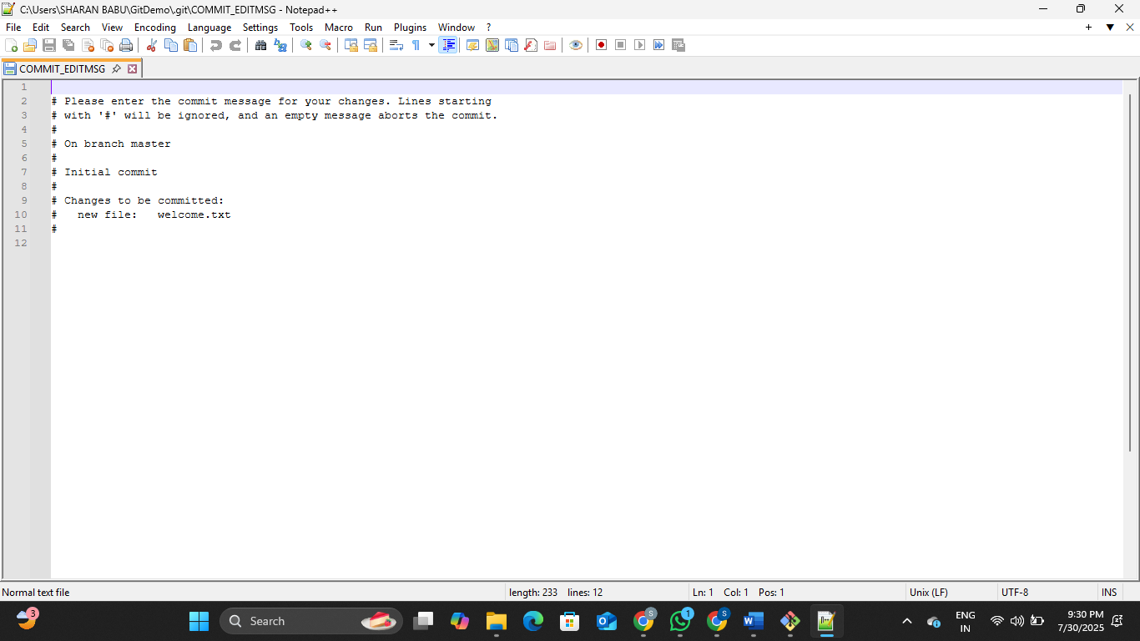

SHARANBABU_B@DESKTOP-MN322RQ MINGW64 ~ (master)

$ git remote add origin https://gitlab.com/sharanbabub-group/GitDemo

SHARANBABU_B@DESKTOP-MN322RQ MINGW64 ~ (master)

$ git remote -v

origin https://gitlab.com/sharanbabub-group/GitDemo (fetch)

origin https://gitlab.com/sharanbabub-group/GitDemo (push)

SHARANBABU_B@DESKTOP-MN322RQ MINGW64 ~/GitDemo (master)

$ ls

welcome.txt

SHARANBABU_B@DESKTOP-MN322RQ MINGW64 ~/GitDemo (master)

$ git add welcome.txt

SHARANBABU_B@DESKTOP-MN322RQ MINGW64 ~/GitDemo (master)

$ git commit -m "Initial commit - added welcome.txt"

[master (root-commit) 486da77] Initial commit - added welcome.txt

1 file changed, 1 insertion(+)

create mode 100644 welcome.txt

SHARANBABU_B@DESKTOP-MN322RQ MINGW64 ~/GitDemo (master)

$ git push -u origin master

info: please complete authentication in your browser...

Enumerating objects: 3, done.

Counting objects: 100% (3/3), done.

Writing objects: 100% (3/3), 260 bytes | 86.00 KiB/s, done.

Total 3 (delta 0), reused 0 (delta 0), pack-reused 0 (from 0)

remote:

remote: To create a merge request for master, visit:

remote: https://gitlab.com/sharanbabub-group/GitDemo/-/merge_requests/new?merge_request%5Bsource_branch%5D=master

remote:

To https://gitlab.com/sharanbabub-group/GitDemo.git

* [new branch] master -> master

branch 'master' set up to track 'origin/master'.

SHARANBABU_B@DESKTOP-MN322RQ MINGW64 ~/GitDemo (master)

$ git push origin master

Everything up-to-date

**Exercise 2:**   
Create a **“.log”** file and a **log folder** in the working directory of Git. Update the **.gitignore** file in such a way that on committing, these files (.log extensions and log folders) are ignored.

Verify if the git status reflects the same about working directory, local repository and git repository.

SHARANBABU_B@DESKTOP-MN322RQ MINGW64 ~ (master)

$ echo "This is a log file." > test.log

SHARANBABU_B@DESKTOP-MN322RQ MINGW64 ~ (master)

$ mkdir log

SHARANBABU_B@DESKTOP-MN322RQ MINGW64 ~ (master)

$ echo "Inside log folder." > log/info.txt

SHARANBABU_B@DESKTOP-MN322RQ MINGW64 ~ (master)

$ touch .gitignore

SHARANBABU_B@DESKTOP-MN322RQ MINGW64 ~ (master)

$ notepad++ .gitignore

**.gitignore:**

SHARANBABU_B@DESKTOP-MN322RQ MINGW64 ~ (master)

$ git status

On branch master

No commits yet

Untracked files:

(use "git add <file>..." to include in what will be committed)

.bash_history

.docker/

.eclipse/

.gitconfig

.gitignore

.idlerc/

.lesshst

.m2/

.nuget/

.p2/

.redhat/

.sts4/

.vscode/

AppData/

Contacts/

Desktop/

Downloads/

Favorites/

GitDemo/

IntelGraphicsProfiles/

Learning_Program_Solutions/

Links/

NTUSER.DAT

NTUSER.DAT{139b56a9-356b-11f0-969e-85be75f19ede}.TM.blf

NTUSER.DAT{139b56a9-356b-11f0-969e-85be75f19ede}.TMContainer00000000000000000001.regtrans-ms

NTUSER.DAT{139b56a9-356b-11f0-969e-85be75f19ede}.TMContainer00000000000000000002.regtrans-ms

OneDrive/

Saved Games/

Searches/

bash

eclipse/

ntuser.dat.LOG1

ntuser.dat.LOG2

ntuser.ini

welcome.txt

nothing added to commit but untracked files present (use "git add" to track)

SHARANBABU_B@DESKTOP-MN322RQ MINGW64 ~ (master)

$ git commit -m "Added .gitignore to ignore log files and folders"

On branch master

Initial commit

Untracked files:

(use "git add <file>..." to include in what will be committed)

.bash_history

.docker/

.eclipse/

.gitconfig

.gitignore

.idlerc/

.lesshst

.m2/

.nuget/

.p2/

.redhat/

.sts4/

.vscode/

Contacts/

Desktop/

Downloads/

Favorites/

GitDemo/

IntelGraphicsProfiles/

Learning_Program_Solutions/

Links/

NTUSER.DAT

NTUSER.DAT{139b56a9-356b-11f0-969e-85be75f19ede}.TM.blf

NTUSER.DAT{139b56a9-356b-11f0-969e-85be75f19ede}.TMContainer00000000000000000001.regtrans-ms

NTUSER.DAT{139b56a9-356b-11f0-969e-85be75f19ede}.TMContainer00000000000000000002.regtrans-ms

OneDrive/

Saved Games/

Searches/

bash

eclipse/

ntuser.dat.LOG1

ntuser.dat.LOG2

ntuser.ini

welcome.txt

nothing added to commit but untracked files present (use "git add" to track)

SHARANBABU_B@DESKTOP-MN322RQ MINGW64 ~ (master)

$ git check-ignore -v test.log

.gitignore:1:*.log test.log

**Exercise 3:**

Please follow the instruction to complete the hands-on. Each instruction expects a command for the Git Bash.

**Branching:**

1. Create a new branch **“GitNewBranch”.**
2. List all the local and remote branches available in the current trunk. Observe the “*” mark which denote the current pointing branch.
3. Switch to the newly created branch. Add some files to it with some contents.
4. Commit the changes to the branch.
5. Check the status with **“git status”** command.

**Merging:**

1. Switch to the master
2. List out all the differences between trunk and branch. These provide the differences in command line interface.
3. List out all the visual differences between master and branch using **P4Merge tool**.
4. Merge the source branch to the trunk.
5. Observe the logging after merging using **“git log –oneline –graph –decorate”**
6. Delete the branch after merging with the trunk and observe the git status.

SHARANBABU_B@DESKTOP-MN322RQ MINGW64 ~/GitDemo (master)

$ git init -b main

warning: re-init: ignored --initial-branch=main

Reinitialized existing Git repository in C:/Users/SHARAN BABU/GitDemo/.git/

SHARANBABU_B@DESKTOP-MN322RQ MINGW64 ~/GitDemo (master)

$ echo "This is the main branch content" > base.txt

SHARANBABU_B@DESKTOP-MN322RQ MINGW64 ~/GitDemo (master)

$ git add base.txt

warning: in the working copy of 'base.txt', LF will be replaced by CRLF the next time Git touches it

SHARANBABU_B@DESKTOP-MN322RQ MINGW64 ~/GitDemo (master)

$ git commit -m "Initial commit on main"

[master b04d527] Initial commit on main

1 file changed, 1 insertion(+)

create mode 100644 base.txt

SHARANBABU_B@DESKTOP-MN322RQ MINGW64 ~/GitDemo (master)

$ git checkout -b GitNewBranch

Switched to a new branch 'GitNewBranch'

SHARANBABU_B@DESKTOP-MN322RQ MINGW64 ~/GitDemo (GitNewBranch)

$ git branch

* GitNewBranch

master

SHARANBABU_B@DESKTOP-MN322RQ MINGW64 ~/GitDemo (GitNewBranch)

$ git branch -r

origin/master

SHARANBABU_B@DESKTOP-MN322RQ MINGW64 ~/GitDemo (GitNewBranch)

$ echo "This file was added in GitNewBranch" > feature.txt

SHARANBABU_B@DESKTOP-MN322RQ MINGW64 ~/GitDemo (GitNewBranch)

$ git add feature.txt

warning: in the working copy of 'feature.txt', LF will be replaced by CRLF the next time Git touches it

SHARANBABU_B@DESKTOP-MN322RQ MINGW64 ~/GitDemo (GitNewBranch)

$ git commit -m "Added feature.txt in GitNewBranch"

[GitNewBranch b9fe0f1] Added feature.txt in GitNewBranch

1 file changed, 1 insertion(+)

create mode 100644 feature.txt

SHARANBABU_B@DESKTOP-MN322RQ MINGW64 ~/GitDemo (GitNewBranch)

$ git status

On branch GitNewBranch

nothing to commit, working tree clean

SHARANBABU_B@DESKTOP-MN322RQ MINGW64 ~/GitDemo (GitNewBranch)

$ git checkout main

error: pathspec 'main' did not match any file(s) known to git

SHARANBABU_B@DESKTOP-MN322RQ MINGW64 ~/GitDemo (GitNewBranch)

$ git diff GitNewBranch

SHARANBABU_B@DESKTOP-MN322RQ MINGW64 ~/GitDemo (GitNewBranch)

$ git mergetool

This message is displayed because 'merge.tool' is not configured.

See 'git mergetool --tool-help' or 'git help config' for more details.

'git mergetool' will now attempt to use one of the following tools:

opendiff kdiff3 tkdiff xxdiff meld tortoisemerge gvimdiff diffuse diffmerge ecmerge p4merge araxis bc codecompare smerge emerge vimdiff nvimdiff

No files need merging

SHARANBABU_B@DESKTOP-MN322RQ MINGW64 ~/GitDemo (GitNewBranch)

$ git merge GitNewBranch

Already up to date.

SHARANBABU_B@DESKTOP-MN322RQ MINGW64 ~/GitDemo (GitNewBranch)

$ git log --oneline --graph --decorate

* b9fe0f1 (**HEAD** -> **GitNewBranch**) Added feature.txt in GitNewBranch

* b04d527 (**master**) Initial commit on main

* 486da77 (**origin/master**) Initial commit - added welcome.txt

SHARANBABU_B@DESKTOP-MN322RQ MINGW64 ~/GitDemo (GitNewBranch)

$ git branch -d GitNewBranch

error: cannot delete branch 'GitNewBranch' used by worktree at 'C:/Users/SHARAN BABU/GitDemo'

SHARANBABU_B@DESKTOP-MN322RQ MINGW64 ~/GitDemo (GitNewBranch)

$ git status

On branch GitNewBranch

nothing to commit, working tree clean

**Exercise 4:**

Please follow the instructions to complete the hands-on. Each instruction expect a command for the Git Bash.

1. Verify if master is in clean state.
2. Create a branch **“GitWork”.** Add a file “hello.xml”.
3. Update the content of “hello.xml” and observe the status
4. Commit the changes to reflect in the branch
5. Switch to master.
6. Add a file **“hello.xml”** to the master and add some different content than previous.
7. Commit the changes to the master
8. Observe the log by executing **“git log –oneline –graph –decorate –all”**
9. Check the differences with Git diff tool
10. For better visualization, use P4Merge tool to list out all the differences between master and branch
11. Merge the bran to the master
12. Observe the git mark up.
13. Use 3-way merge tool to resolve the conflict
14. Commit the changes to the master, once done with conflict
15. Observe the git status and add backup file to the .gitignore file.
16. Commit the changes to the .gitignore
17. List out all the available branches
18. Delete the branch, which merge to master.
19. Observe the log by executing **“git log –oneline –graph –decorate”**

SHARANBABU_B@DESKTOP-MN322RQ MINGW64 ~/GitDemo (GitNewBranch)

$ git checkout master

Switched to branch 'master'

Your branch is ahead of 'origin/master' by 1 commit.

(use "git push" to publish your local commits)

SHARANBABU_B@DESKTOP-MN322RQ MINGW64 ~/GitDemo (master)

$ git status

On branch master

Your branch is ahead of 'origin/master' by 1 commit.

(use "git push" to publish your local commits)

nothing to commit, working tree clean

SHARANBABU_B@DESKTOP-MN322RQ MINGW64 ~/GitDemo (master)

$ git checkout -b GitWork

Switched to a new branch 'GitWork'

SHARANBABU_B@DESKTOP-MN322RQ MINGW64 ~/GitDemo (GitWork)

$ echo "<greeting>Hello from GitWork branch</greeting>" > hello.xml

SHARANBABU_B@DESKTOP-MN322RQ MINGW64 ~/GitDemo (GitWork)

$ git status

On branch GitWork

Untracked files:

(use "git add <file>..." to include in what will be committed)

hello.xml

nothing added to commit but untracked files present (use "git add" to track)

SHARANBABU_B@DESKTOP-MN322RQ MINGW64 ~/GitDemo (GitWork)

$ git add hello.xml

warning: in the working copy of 'hello.xml', LF will be replaced by CRLF the next time Git touches it

SHARANBABU_B@DESKTOP-MN322RQ MINGW64 ~/GitDemo (GitWork)

$ git commit -m "Added hello.xml in GitWork"

[GitWork 048d4aa] Added hello.xml in GitWork

1 file changed, 1 insertion(+)

create mode 100644 hello.xml

SHARANBABU_B@DESKTOP-MN322RQ MINGW64 ~/GitDemo (GitWork)

$ git checkout master

Switched to branch 'master'

Your branch is ahead of 'origin/master' by 1 commit.

(use "git push" to publish your local commits)

SHARANBABU_B@DESKTOP-MN322RQ MINGW64 ~/GitDemo (master)

$ echo "<greeting>Hello from master branch</greeting>" > hello.xml

SHARANBABU_B@DESKTOP-MN322RQ MINGW64 ~/GitDemo (master)

$ git add hello.xml

warning: in the working copy of 'hello.xml', LF will be replaced by CRLF the next time Git touches it

SHARANBABU_B@DESKTOP-MN322RQ MINGW64 ~/GitDemo (master)

$ git commit -m "Added hello.xml in master"

[master ba16449] Added hello.xml in master

1 file changed, 1 insertion(+)

create mode 100644 hello.xml

SHARANBABU_B@DESKTOP-MN322RQ MINGW64 ~/GitDemo (master)

$ git log --oneline --graph --decorate --all

* ba16449 (**HEAD** -> **master**) Added hello.xml in master

| * 048d4aa (**GitWork**) Added hello.xml in GitWork

|/

| * b9fe0f1 (**GitNewBranch**) Added feature.txt in GitNewBranch

|/

* b04d527 Initial commit on main

* 486da77 (**origin/master**) Initial commit - added welcome.txt

SHARANBABU_B@DESKTOP-MN322RQ MINGW64 ~/GitDemo (master)

$ git diff GitWork

**diff --git a/hello.xml b/hello.xml**

**index 181e8d0..2d8d754 100644**

**--- a/hello.xml**

**+++ b/hello.xml**

@@ -1 +1 @@

-<greeting>Hello from GitWork branch</greeting>

+<greeting>Hello from master branch</greeting>

SHARANBABU_B@DESKTOP-MN322RQ MINGW64 ~/GitDemo (master)

$ git mergetool

This message is displayed because 'merge.tool' is not configured.

See 'git mergetool --tool-help' or 'git help config' for more details.

'git mergetool' will now attempt to use one of the following tools:

opendiff kdiff3 tkdiff xxdiff meld tortoisemerge gvimdiff diffuse diffmerge ecmerge p4merge araxis bc codecompare smerge emerge vimdiff nvimdiff

No files need merging

SHARANBABU_B@DESKTOP-MN322RQ MINGW64 ~/GitDemo (master)

$ git merge GitWork

Auto-merging hello.xml

CONFLICT (add/add): Merge conflict in hello.xml

Automatic merge failed; fix conflicts and then commit the result.

**hello.xml**

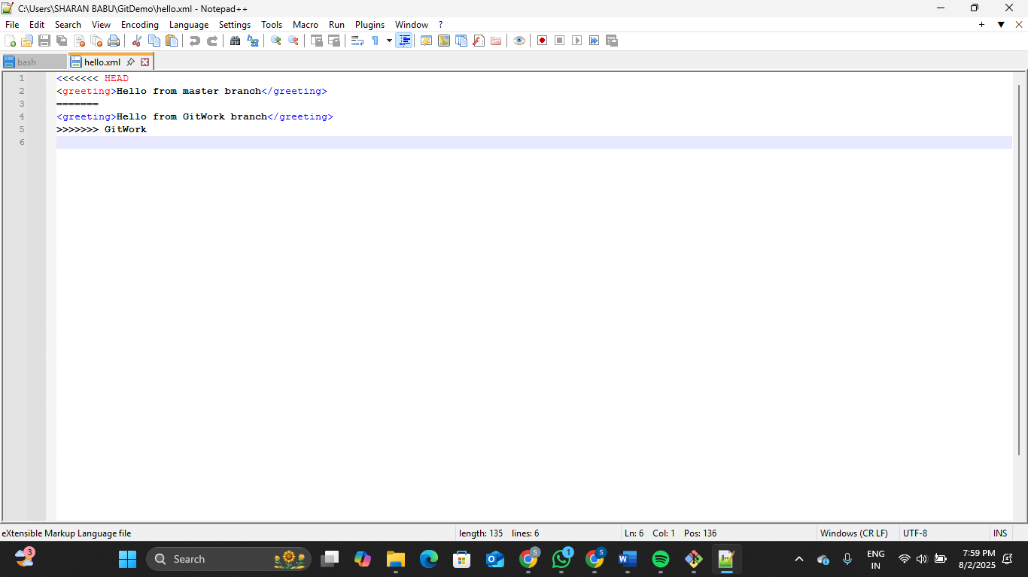

**After editing the hello.xml file:**

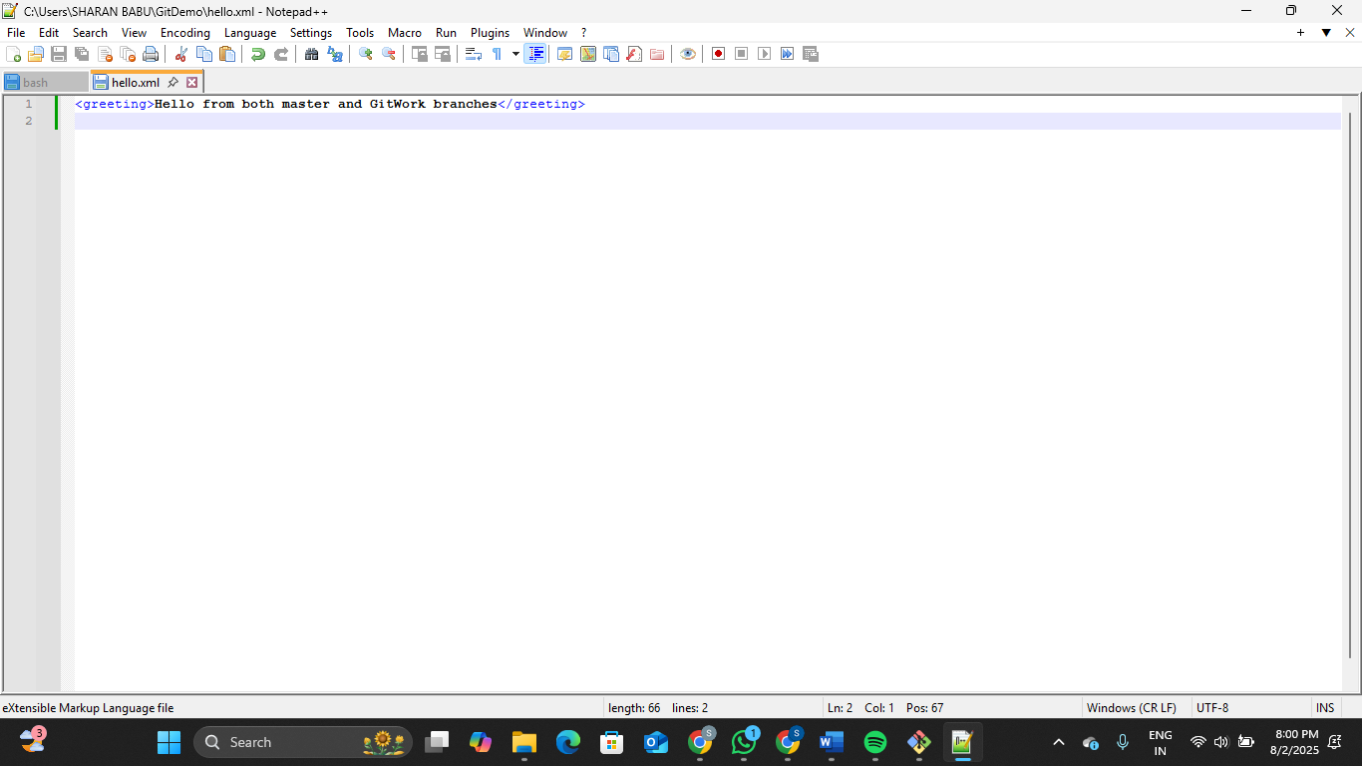

SHARANBABU_B@DESKTOP-MN322RQ MINGW64 ~/GitDemo (master|MERGING)

$ git add hello.xml

SHARANBABU_B@DESKTOP-MN322RQ MINGW64 ~/GitDemo (master|MERGING)

$ git commit -m "Resolved merge conflict in hello.xml"

[master 6e3ed3a] Resolved merge conflict in hello.xml

SHARANBABU_B@DESKTOP-MN322RQ MINGW64 ~/GitDemo (master)

$ echo "*.orig" >> .gitignore

SHARANBABU_B@DESKTOP-MN322RQ MINGW64 ~/GitDemo (master)

$ git add .gitignore

warning: in the working copy of '.gitignore', LF will be replaced by CRLF the next time Git touches it

SHARANBABU_B@DESKTOP-MN322RQ MINGW64 ~/GitDemo (master)

$ git commit -m "Ignored backup files from merge"

[master 98c9b6f] Ignored backup files from merge

1 file changed, 1 insertion(+)

create mode 100644 .gitignore

SHARANBABU_B@DESKTOP-MN322RQ MINGW64 ~/GitDemo (master)

$ git branch

GitNewBranch

GitWork

* master

SHARANBABU_B@DESKTOP-MN322RQ MINGW64 ~/GitDemo (master)

$ git branch -d GitWork

Deleted branch GitWork (was 048d4aa).

SHARANBABU_B@DESKTOP-MN322RQ MINGW64 ~/GitDemo (master)

$ git log --oneline --graph --decorate

* 98c9b6f (**HEAD** -> **master**) Ignored backup files from merge

* 6e3ed3a Resolved merge conflict in hello.xml

|\

| * 048d4aa Added hello.xml in GitWork

* | ba16449 Added hello.xml in master

|/

* b04d527 Initial commit on main

* 486da77 (**origin/master**) Initial commit - added welcome.txt

**Exercise 5:**

Please follow the instructions to complete the hands-on. Each instruction expects a command for the Git Bash.

1. Verify if master is in clean state.
2. List out all the available branches.
3. Pull the remote git repository to the master
4. Push the changes, which are pending from **“Git-T03-HOL_002”** to the remote repository.
5. Observe if the changes are reflected in the remote repository.

SHARANBABU_B@DESKTOP-MN322RQ MINGW64 ~/GitDemo (master)

$ git checkout master

Already on 'master'

Your branch is ahead of 'origin/master' by 5 commits.

(use "git push" to publish your local commits)

SHARANBABU_B@DESKTOP-MN322RQ MINGW64 ~/GitDemo (master)

$ git status

On branch master

Your branch is ahead of 'origin/master' by 5 commits.

(use "git push" to publish your local commits)

nothing to commit, working tree clean

SHARANBABU_B@DESKTOP-MN322RQ MINGW64 ~/GitDemo (master)

$ git branch

GitNewBranch

* master

SHARANBABU_B@DESKTOP-MN322RQ MINGW64 ~/GitDemo (master)

$ git branch -r

origin/master

SHARANBABU_B@DESKTOP-MN322RQ MINGW64 ~/GitDemo (master)

$ git pull origin master

From https://gitlab.com/sharanbabub-group/GitDemo

* branch master -> FETCH_HEAD

Already up to date.

SHARANBABU_B@DESKTOP-MN322RQ MINGW64 ~/GitDemo (master)

$ git push origin master

Enumerating objects: 16, done.

Counting objects: 100% (16/16), done.

Delta compression using up to 4 threads

Compressing objects: 100% (11/11), done.

Writing objects: 100% (15/15), 1.49 KiB | 152.00 KiB/s, done.

Total 15 (delta 2), reused 0 (delta 0), pack-reused 0 (from 0)

remote:

remote: View merge request for master:

remote: https://gitlab.com/sharanbabub-group/GitDemo/-/merge_requests/1

remote:

To https://gitlab.com/sharanbabub-group/GitDemo.git

486da77..98c9b6f master -> master

**GitLab:** 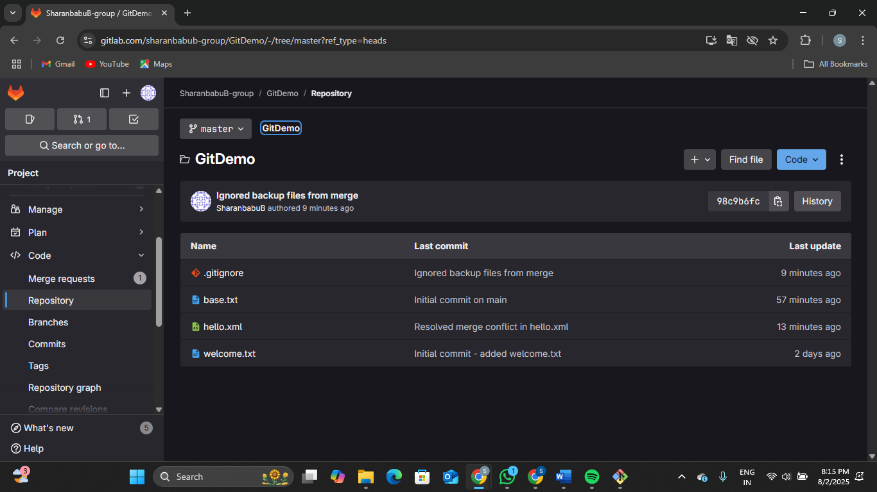

**base.txt:**

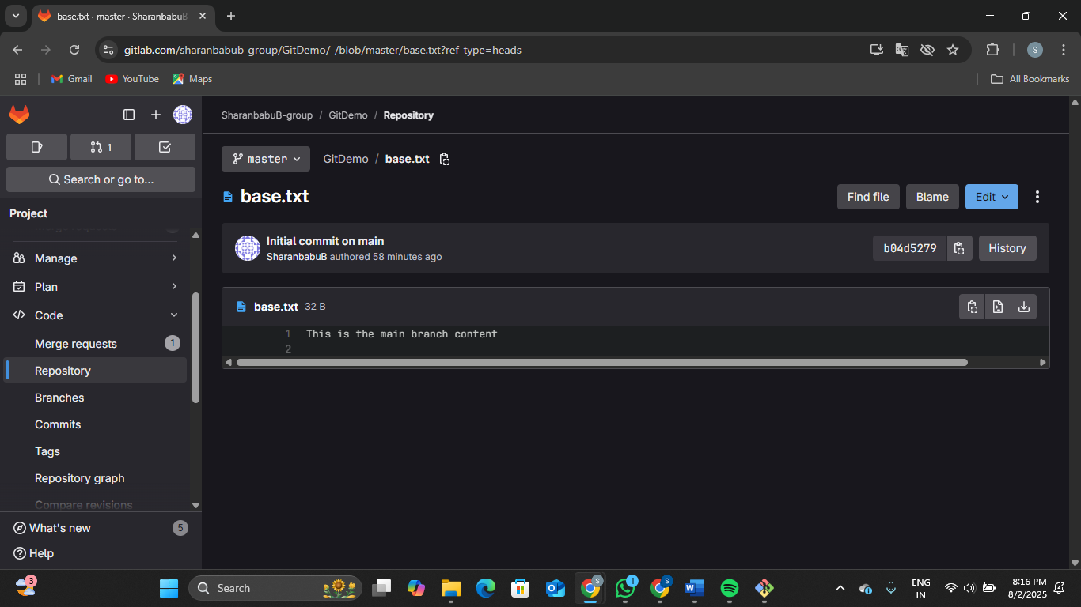

**.gitignore:**

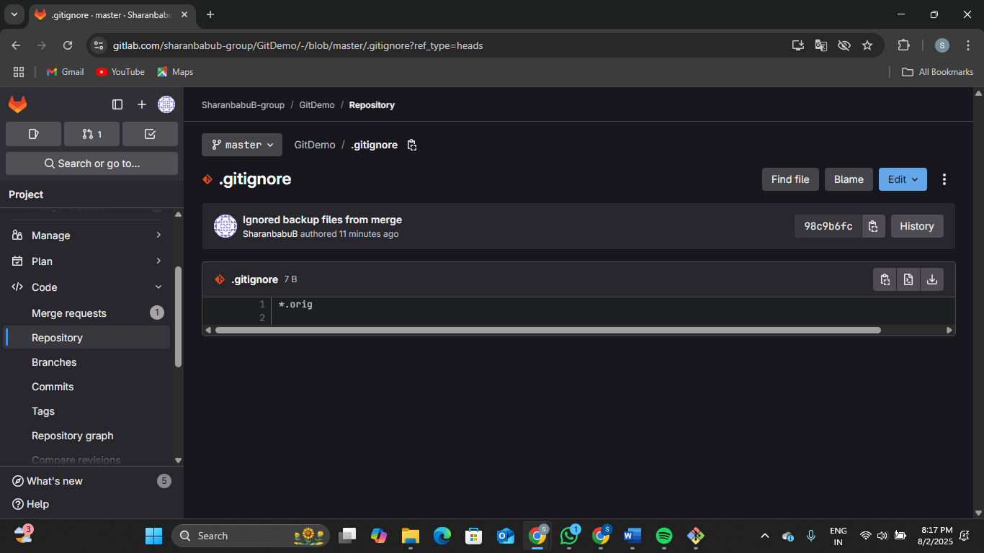

**hello.xml:**

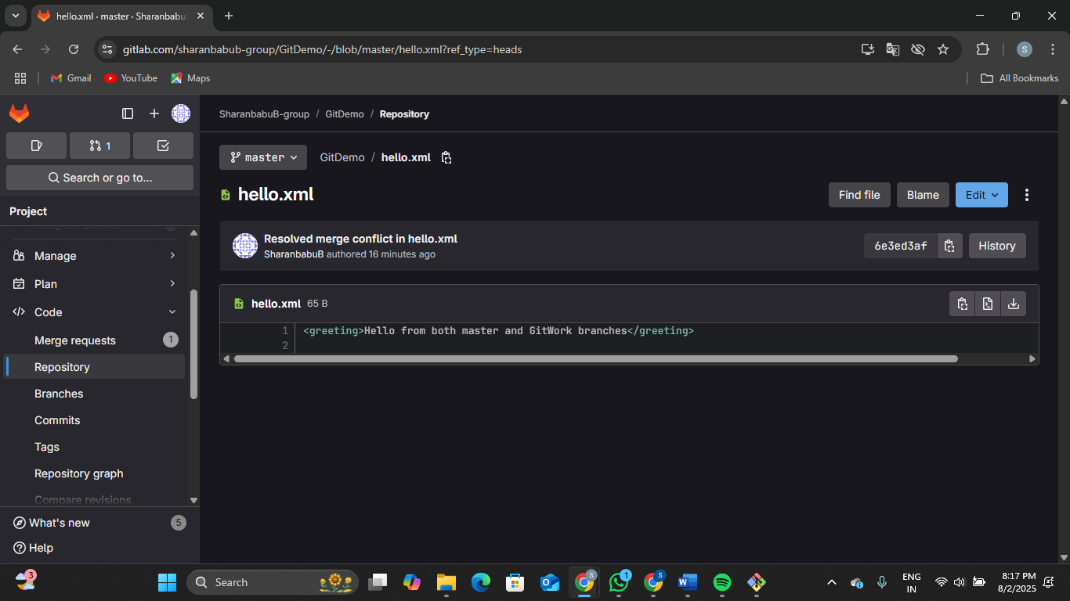

**welcome.txt:**

